Steelpump Float Switch Installation

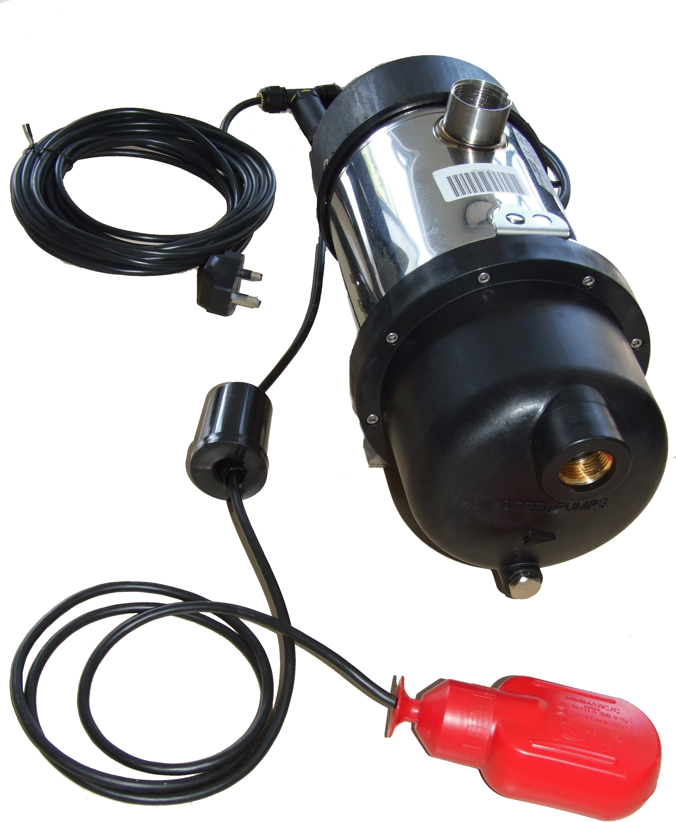

The float-switch and weight are supplied attached to the SteelPump using an IP68 3-way cable joiner.

The cable lengths are as follows:

Cable Section
Length (metres)
Pump to Cable Joiner
2
Cable Joiner to Floatswitch
2
Cable Joiner to Plug
8

Installation
To ensure the SteelPump does not run dry the float-switch must be secured at a suitable position above the inlet level of the SteelPump inside the rainwater storage tank.

It is recommended that the float-switch cable is clipped to the rainwater inlet pipe, with the power cable running along the rainwater inlet pipe back to the tank turret (and then via Service duct to the power source).

The power to the pump will be stopped when the float-switch is in the ‘down’ position.
The pump will restart when the float-switch is in the ‘up’ position.

Distance ‘a’ on the diagram below can be set by moving the weight further from the float-switch. Increasing distance ‘a’ increases the difference in rainwater level required between the tilt switch being in an ‘up’ position (on) and in a ‘down position’ (off).



